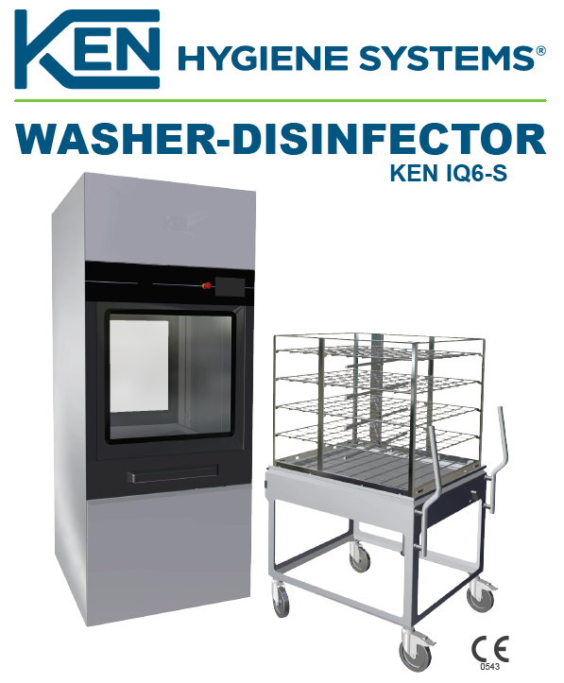

Intended Use
The KEN IQ6-S Washer-Disinfector is a fully automatic, washer designed for use in hospitals and clinics. The system provides up to 40 different programs for cleaning and disinfection of surgical instruments and utensils. Each of the programs can include up to 10 program phases and may be adjusted to specific user requirements.
IQ6-S is intended for use in hospitals or the health care sector for washing and disinfection of:
- Surgical instruments
- Anaesthetic equipment
- Bowls, dishes, receivers, utensils, glassware, etc.
To meet the specific requirements for cleaning of the above devices a variety of racks are designed for the machine. All items to be cleaned in this machine must tolerate heat disinfection
Features
The washer/disinfector comes in an automatic sliding one or two doors model as well as in a manual drop down version, one or two doors. The machine can be electrically heated or both electrically and steam heated. IQ6 has been designed in the form of a basic structure to which features may be added to increase flexibility and meet your specific needs.
This flexibility applies to features such as:
- Various racks
- Number of dosage pumps
- Number of water connections
- Printer
- Automatic loader/unloader
- RFID monitoring
The advantages of the Ken IQ6:
- Sliding doors with unique features and soft close
- 34 minutes validated program incl. drying
- Low carbon footprint
- Remote service
- Graphical touch screen with swipe
- Minimal space requirements
- Hygienic and user-friendly surfaces
- Side by side installation without space

Safety Instructions
Personal Safety | The responsible body must offer regular training of all personnel who is involved in operation and maintenance of the equipment, including emergency procedures in case any toxic or pathogenic substances are released into the environment by accident. Stated below are conditions where hazards might occur if the machine is not handled according to instructions.
Electric Shock | Electrical components that might pose hazards are placed behind covers which  can only be removed using a tool. These covers may only be removed by specially trained staff.
Chemicals/corrosion | Safety precautions must be taken against chemical exposure when handling chemical canisters. Always wear eye protection and safety gloves. Detergents are caustic and can cause severe damage on exposed skin. Avoid any contact with eyes, skin and mouth. Always follow the chemical supplier’s instructions concerning re-filling or replacement.  Always read the chemical supplier’s Material Safety Data Sheet (MSDS) prior to handling, use and storage of detergents and chemicals
Inhalation of vapours | Normally, use of approved chemicals for washer/disinfector machines will not cause any health-related hazards.  In case the detergent supplier or the health authorities state that the chemicals used might release fumes hazardous to inhale, ventilation should be connected directly to machine. See Material Safety Data Sheet (MSDS).
Hot surfaces | Use caution when pulling out the rack after program completion. The rack and items  may be hot and contain hot water. After program completion the filter and washing  arms may be hot. Allow to cool or use protective gloves. Avoid contact with the  heating element.
Sharp items | Be careful during cleaning/maintenance of wash chamber. Sharp items might have  fallen from racks during washing and disinfection and remain in the wash chamber

Daily Maintenance:

Daily machine check | As part of your quality control programme a daily machine check can be activated. In this case the following list of items to check will appear on the display every day. Carefully go through each item and lastly push” Accept” icon.  The intervals of machine check can be adjusted by specially trained staff. | 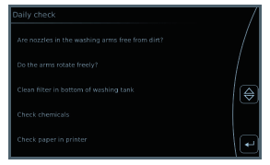
 | All inside parts of the machine might be hot. Use protective gloves during machine check.
” Are the nozzles in the washing arms free from dirt?” | In case a clogged nozzle cannot be cleaned from the outside, the plug at the end of the washing arms can be removed and thereby the nozzle may be cleaned from the inside. Otherwise, the washing arm must be dismounted and rinsed | 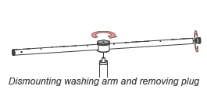
“Do the arms rotate freely?” | Inspect washing arms for full 360° rotation. All arms should rotate freely. As an option the machine can be equipped with automatic monitoring of the rotation of the washing arms.
“Clean filter in bottom of washing tank” | Remove filter and clear away waste from the tank bottom. Clean the filter and put it back in place. The filter might be hot if a wash cycle just has been completed. Avoid contact with the heating element in the ash tank.  Be careful when cleaning filter and tank bottom, sharp items may occur
“Check chemicals” | Inspect supply levels of detergent, instrument lubricant, etc., and replace as necessary. Always follow the chemical supplier’s instructions and procedures from the Material Safety Data Sheet (MSDS) prior to the handling, use and storage of chemicals. Use protection when working with chemicals. Wear safety glasses and gloves, also when cleaning from spillage and leakage. Detergents are alkalic or acidic and can cause severe injury to exposed skin. Avoid contact with skin, eyes and mouth. | 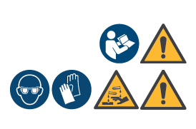  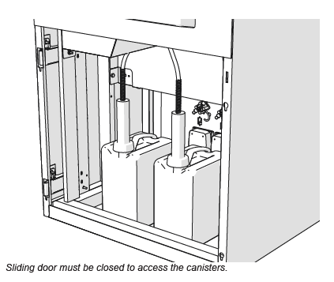
“Check paper in printer” | (only present if machine is equipped with a printer)  Open the printer to check if it contains sufficient paper. | 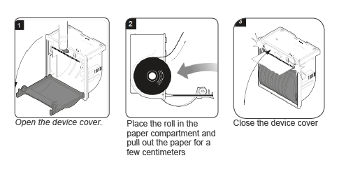
Daily maintenance | Clean the exterior surfaces of machine with a moist cloth. Use detergents intended for cleaning stainless steel and glass only.  Do not use water hose or pressure washer as the machine is not waterproof.
Visual inspection | Upon unloading machine check that the washed and disinfected goods is actually clean. If no error notifications have appeared and an inspection of the machine does not reveal any irregularities and your items are still soiled the cause may be due to incorrect loading of baskets and racks or to incorrect dosage of detergent.

Additional Information:
Control panel | 