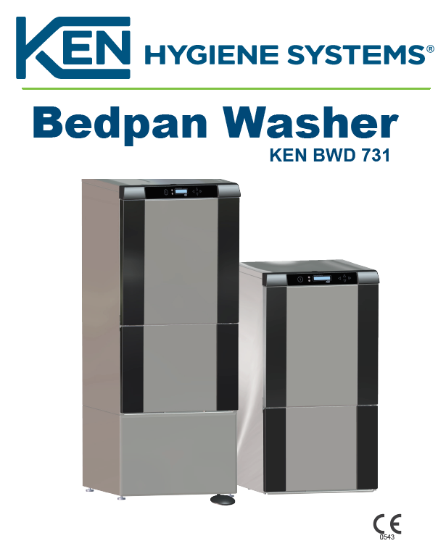

**Intended Use:**

The KEN 731 Bedpan Washer-Disinfector is intended for washing and disinfection of bedpans, urine bottles, washing bowls, suction glasses and similar utensils. All items to be cleaned in these machines must endure heat disinfection. Pathogenic bacteria (bacteria that provoke disease) are deactivated by means of heat disinfection. Consequently, the disinfected utensils represent no infection risk

These machines should not be used for tubular items, such as rigid scopes, anaesthesia hoses and similar items.

**Features:**

The KEN 731 Bedpan Washer-Disinfector can be supplied as wall-mounted or floor-mounted, and as under counter model. The door is operated automatically by pressing the start button.

The KEN 731 Bedpan Washer-Disinfector features an integrated water tank and pump which means that the machine does not depend on the in house water pressure. Together with the thoroughly tested nozzle system, this ensures effective washing with a minimum consumption of water and energy. Furthermore, the water system has been designed for maximum protection against back-flow of the water into the drinking water lines. This protection is achieved through an air gap which complies with present EN-standards. Foot operation is possible (option). The machine is computer-controlled and information about the program cycle appears on the display.

**Safety Instructions**

|  |  |  |
| --- | --- | --- |
| **Personal Safety** | The responsible body must offer regular training of all personnel who is involved in operation and maintenance of the equipment, including emergency procedures in case any toxic or pathogenic substances are released into the environment by acci­dent. Stated below are conditions where hazards might occur if the machine is not handled according to instructions. |  |
| **Electric Shock** | Electrical components that might pose hazards are placed behind covers which  can only be removed using a tool. These covers may only be removed by specially trained staff. |  |
| **Chemicals/corrosion** | Safety precautions must be taken against chemical exposure when handling chemical canisters. Always wear eye protection and safety gloves. Detergents are caustic and can cause severe damage on exposed skin. Avoid any contact with eyes, skin and mouth. Always follow the chemical supplier’s instructions concerning re-filling or replacement.  Always read the chemical supplier’s Material Safety Data Sheet (MSDS) prior to handling, use and storage of detergents and chemicals |  |
| **Inhalation of vapours** | Normally, use of approved chemicals for washer/disinfector machines will not cause any health-related hazards.  In case the detergent supplier or the health authorities state that the chemicals used might release fumes hazardous to inhale, ventilation should be connected directly to machine. See Material Safety Data Sheet (MSDS). |  |
| **Hot surfaces** | Use caution when pulling out the rack after program completion. The rack and items  may be hot and contain hot water. After program completion the filter and washing  arms may be hot. Allow to cool or use protective gloves. Avoid contact with the  heating element. |  |
| **Scalding** | The machine has protection against scalding in the event of unintentional opening of  the door. |  |
| **Sharp items** | Be careful during cleaning/maintenance of wash chamber. Sharp items might have  fallen from racks during washing and disinfection and remain in the wash chamber |  |

**Daily Maintenance:**

|  |  |  |
| --- | --- | --- |
| **Daily machine check** | Clean the outer surfaces of the machine with a moist cloth, possibly using a polishing agent for stainless steel. |  |
| **Detergents** | Every day check the level of detergent in the can/cans. |  |
| **Door gasket:** | Check the door gasket every day. Check that it is unbroken and correctly in position.  If it shows signs of ageing, cracking, miscolouring and so on, it should be replaced.  Replacement of the door gasket should be carried out by a service engineer. |  |
| **Emptying the Combitank** | In addition to the daily maintenance, we recommend that preventive maintenance is  carried out to ensure optimum machine functions at all times.  In case of long standing still periods, the combi tank of the bedpan washer should  be emptied. Emptying (approx. 3 litres) is carried out via the hose attached to the water  inlet on the combitank |  |
| **Cold Rinse before changing the hose** | If the machine is connected to Chemical 2 (optional), the combi tank may also be emptied via the hose on the pressure side of the dosage pump. When changing the hose in the dosage pump it is important to pay attention to the danger of scalding (do  a cold rinse before changing the hose). |  |
| **Safety Recommendation** | If the machine is emptied immediately after the disinfection the water will be very hot, and there will be a risk of getting scalded. It is recommended to do a cold rinse before  emptying. |  |
| **Safety Pre-Caution** | Use protective glasses and gloves when emptying the combitank. |  |

**Additional Information:**

|  |
| --- |
| **Control panel** |