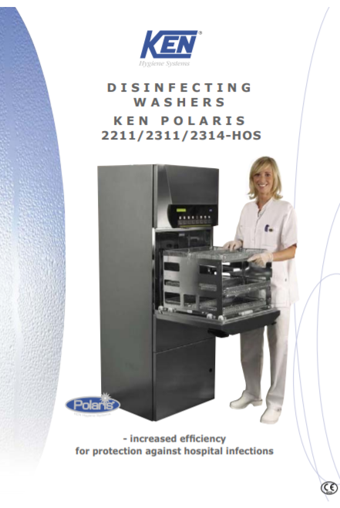

Intended Use
The KEN Polaris Washer-Disinfector is a fully automatic, washer designed for use in hospitals and clinics.
The KEN Polaris Series (2211/2311/2314) was intended for use in hospitals or the health care sector for washing and disinfection of:
- Surgical instruments
- Anaesthetic equipment
- Rigid scopes
- Bowls, dishes, receivers, utensils, glassware, etc.
To meet the specific requirements for cleaning of the above devices a variety of racks are designed for the machine. All items to be cleaned in this machine must tolerate heat disinfection
Features
This washer-disinfector range has been designed in the form of a basic structure to which the factory can ad features that make it suit the needs and work assignments of the individual ward (e.g.: bed wards, surgery wards, central sterilising departments, emergency wards/reception, laboratory, etc.).
This flexibility applies to such features as:
- One Or Two Doors
- Number Of Washing Arms
- Pump Size
- Drying Module
- Dosage Pumps, Etc.
In addition, machines can be fitted at the place of use with equipment from KEN's standard basket range - or special-duty baskets can be manufactured to solve a given assignment

Safety Instructions
Personal Safety | The responsible body must offer regular training of all personnel who is involved in operation and maintenance of the equipment, including emergency procedures in case any toxic or pathogenic substances are released into the environment by accident. Stated below are conditions where hazards might occur if the machine is not handled according to instructions.
Electric Shock | Electrical components that might pose hazards are placed behind covers which  can only be removed using a tool. These covers may only be removed by specially trained staff.
Chemicals/corrosion | Safety precautions must be taken against chemical exposure when handling chemical canisters. Always wear eye protection and safety gloves. Detergents are caustic and can cause severe damage on exposed skin. Avoid any contact with eyes, skin and mouth. Always follow the chemical supplier’s instructions concerning re-filling or replacement.  Always read the chemical supplier’s Material Safety Data Sheet (MSDS) prior to handling, use and storage of detergents and chemicals
Inhalation of vapours | Normally, use of approved chemicals for washer/disinfector machines will not cause any health-related hazards.  In case the detergent supplier or the health authorities state that the chemicals used might release fumes hazardous to inhale, ventilation should be connected directly to machine. See Material Safety Data Sheet (MSDS).
Hot surfaces | Use caution when pulling out the rack after program completion. The rack and items  may be hot and contain hot water. After program completion the filter and washing  arms may be hot. Allow to cool or use protective gloves. Avoid contact with the  heating element.
Sharp items | Be careful during cleaning/maintenance of wash chamber. Sharp items might have  fallen from racks during washing and disinfection and remain in the wash chamber

Daily Maintenance:

Daily machine check | Every day, at the first washing the following message will appear on the  display "Machine Check - accept by flashing key".  The time for Machine Check can be adjusted by the technical staff.
Check 1: Spray Arm & Nozzles are clean | When this message has been accepted, the display will automatically ask the  question: "Are the nozzles of the wash arms clean?"  In case a choked up nozzle cannot be cleaned from the outside, the retaining  spring and the plugs at the ends of the wash arms are removed and the  nozzle is cleaned from the inner side of the wash arm.
Check 2: Check if the Wash rotate freely | When this message has been accepted, the display will automatically ask the  question: "Do the wash arms rotate freely?"  Having checked the wash arms this must be accepted by the flashing key
Check 3: Check Filters | When this message has been accepted, the following message will  automatically appear on the display: " Clean filter in bottom of wash  chamber"  Having checked the filter this must be accepted by the flashing key
Check 4: Check Chemistries canisters | When this message has been accepted, the following message will  automatically appear on the display: "Check chemicals in the canisters".  Check the level of the detergent, the rinse aid and other chemical canisters,  if any.
Safety Pre-Caution! | By cleaning of filter and tank bottom be careful about sharp items.
Check 5: Check Door | Door gasket:  Check the door gasket every day. Check that it is unbroken  and correctly placed. If it shows signs of ageing, cracking, miscolouring,  etc., it should be replaced.  Replacement of the door gasket should be carried out by a service  technician.
Check 6: Serving & Maintenance | In addition to the daily maintenance described, it is recommended to carry out regular inspection to ensure that the machine functions optimally at all  times.  All preventive service and maintenance, which require the machine cladding plates to be removed with the use of tools, must only be carried out by specially trained, technical staff

Additional Information:
Control panel

