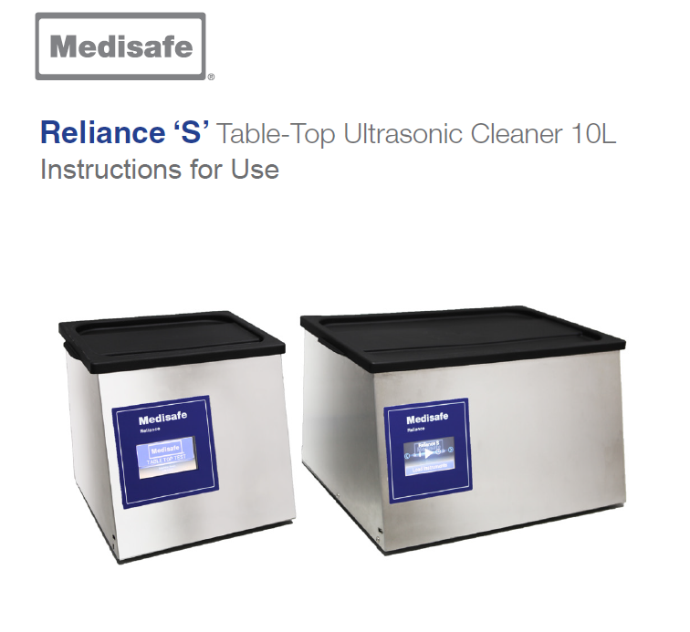

**Intended Use:**

The Medisafe Sonic Irrigator Semi-Automatic is principally intended to clean hollow (cannulated) instruments, surgical instruments, and associated products. This is achieved through a combination of ultrasonic activity and low-frequency Cannulated Pulse Enhancement (CPE) fluid re-circulation to dislodge and flush away unwanted debris from both the outside and the inside (hollow instruments only) of items placed in the wash tank.

**Product features:**

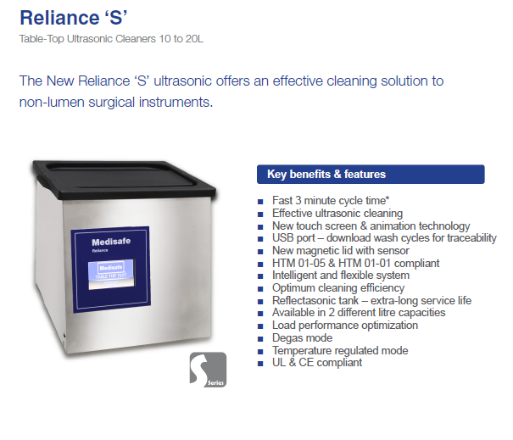

**Technical Specifications**

|  |  |
| --- | --- |
| **Equipment designation** | Reliance S Ultrasonic Cleaner |
| **Classifications** | Medical device class I  Class 1 electrical shock protection, externally powered No applied parts  IP rating: IPX0  Not suitable for use in oxygen-rich environment Designed for continuous use |
| **Intended purpose** | Cleaning of surgical instruments, and associated products. |
| **Operating process** | Ultrasonic activity and water heating. |
| **Ultrasonic system** | **MED511030, MED511020** (10 Litres): 4 piezo-electric transducers **MED512030, MED512020** (20 Litres): 6 piezo-electric transducers Typically operating at 38 to 40 kHz dependent on load. 40 W power per transducer.  Pulsed degas, auto-tune, frequency sweep. |
| **Water temperature monitoring** | Measurement range: +2 ºC to 60 ºC (+36 ºF to 140 ºF)  Temp. display: +5 ºC to 60 ºC (+40 ºF to 140 ºF), accuracy ±0.5. |
| **Drainage system** | Manually operated valve and drain pump |
| **Drain outlet** | 3/4 in. hose tail |
| **Effluent temperature** | Max. +60 ºC (+140 ºF) |
| **Maximum drain flow rate** | less than 15 litre/min. (4 gal/min.) |
| **User interface** | 4.3 in. TFT touch-screen display Time display: minutes and seconds |
| **Audio** | 1 W speaker |
| **Internal clock accuracy** | ±0.5 sec |
| **Internal data storage** | Micro SD flash card, 4 GB (storage of >10,000 cycles) |
| **Real-time clock battery** | CR1220 (5012LC), 35 to 40 mAh, 0.1 mA |
| **Altitude range** | Interior only, altitude up to 2000 m (6562 ft) |
| **Ambient operating temperature range** | +5 ºC to 40 ºC (+41 ºF to 104 ºF) |
| **Maximum humidity** | 80% relative humidity for up to +31 ºC (+88 ºF) decreasing linearly to 50% relative humidity at  +40 ºC (+104 ºF) |
| **Noise generated during operation** | 71 dBA at distance of 1 m (3.3 ft) from front of machine |
| **Heat output during operation** | 205 W (700 BTU/hr) during wash cycle |

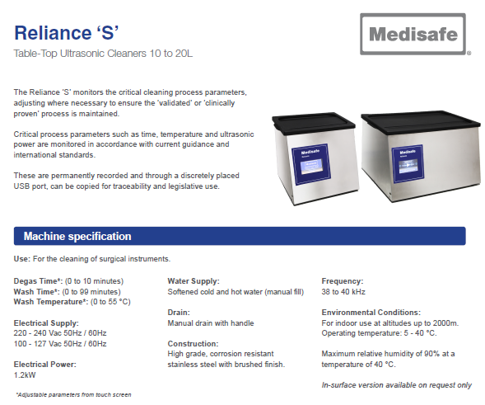

|  |  |  |
| --- | --- | --- |
|  | **MED511020 & MED511030** | **MED512020 & MED512030** |
| **External height** | 319 mm (12.6 in.) | 319 mm (12.6 in.) |
| **External width** | 357 mm (14.1 in.) | 553 mm (21.8 in.) |
| **External depth** | 380 mm (15.0 in.) | 440 mm (17.3 in.) |
| **Net weight (dry)** | 8.8 kg (19.4 lb) | 16.5 kg (36.2 lb) |
| **Operating weight (tank filled)** | 18.4 kg (40.5 lb) | 32.4 kg (71.2 lb) |
|  | MED511020 & MED511030 | MED512020 & MED512030 |
| **Wash tank length** | 290 mm (11.4 in.) | 495 mm (19.4 in.) |
| **Wash tank width** | 230 mm (9.0 in.) | 282 mm (11.1 in.) |
| **Wash tank depth** | 200 mm (7.8 in.) | 150 mm (5.9 in.) |
| **Wash tank liquid volume** | 10 L (2.5 gal) | 20 L (5.2 gal) |
|  | MED511020 & MED511030 | MED512020 & MED512030 |
| **Basket length** | 228 mm (8.9 in.) | 431 mm (16.9 in.) |
| **Basket width** | 187 mm (7.3 in.) | 235 mm (9.2 in.) |
| **Basket depth** | 154 mm (6.0 in.) | 121 mm (4.7 in.) |
| **Maximum load weight** | 3.0 kg (6.6 lb) | 4.0 kg (8.8 lb) |

**Daily Maintenance**

|  |  |
| --- | --- |
|  | **Before every cycle**  Perform the following procedure after each  wash cycle:  **Replace drain filter in wash tank**  Carefully remove the small, caged filter  located in the drain inside the wash  tank. Replace with a new item. |
|  | **Wipe water level sensor in tank**  Carefully wipe any excess moisture or  dirt from the water level sensor using a  lint free cloth, soft brush, or an alcohol  impregnated swab.  **Drain wash tank in the following**  **way:**  Connect hose to drain tap and place  other end into a suitable drain  Open tap on drain valve  Press and hold the ‘speed drain’ button  on front, right-hand side of the unit  until wash tank is empty |

|  |
| --- |
| **Daily Checks**   1. Remove Lid and make sure Vapor Barrier and Lid Magnets are clean and undamaged (Image 8.1).   VAPOR BARRIER  LID MAGNET  LID MAGNET  Image 8.1: Location of Lid Magnets and Vapor Barrier on Lid   1. Remove Basket and make sure it is clean and undamaged. 2. Clean Water Level Sensor with sterile wipe or soft nylon brush (Image 8.2).   **WATER LEVEL SENSOR**  Image 8.2: Location of Water Level Sensor and Drain Filter in Tank   1. Inspect Drain Filter and replace if clogged (Image 8.2). 2. With clean cloth and disinfectant, wipe following;  * All interior surfaces of Tank. * All external surfaces of unit. * All surfaces of Lid.  1. With clean wet cloth, remove any trace of disinfectant from internal and external surfaces of unit and Lid. |

**Additional Information:**

|  |
| --- |
|  |