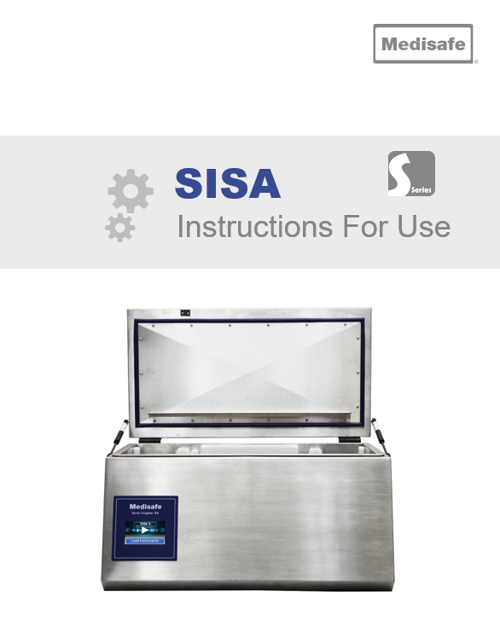

**Intended Use:**

The Medisafe Sonic Irrigator Semi-Automatic is principally intended to clean hollow (cannulated) instruments, surgical instruments, and associated products. This is achieved through a combination of ultrasonic activity and low-frequency Cannulated Pulse Enhancement (CPE) fluid re-circulation to dislodge and flush away unwanted debris from both the outside and the inside (hollow instruments only) of items placed in the wash tank.

**Product features:**

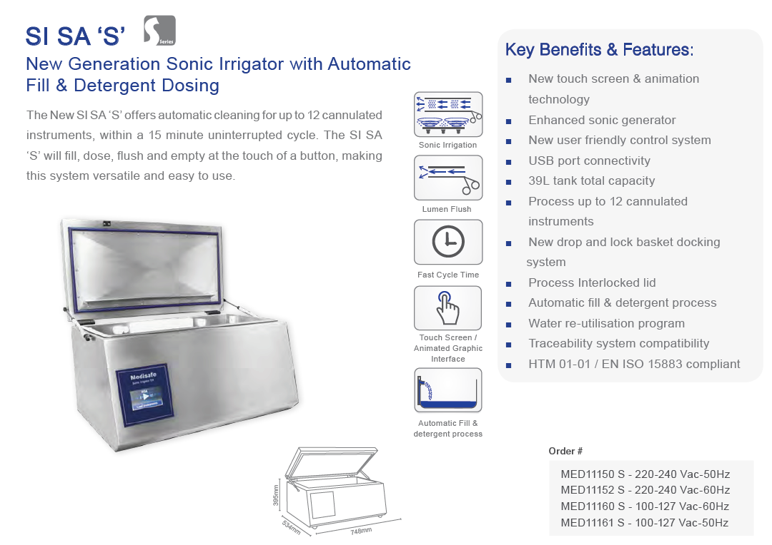

**Technical Specifications**

|  |  |  |  |  |  |  |  |
| --- | --- | --- | --- | --- | --- | --- | --- |
| **General** | | | | | | | |
| Description | | | | Medical Device Class I | | | |
| Intended Purpose | | | | Internal and external cleaning of surgical instruments, hollow-ware, and associated products | | | |
| Operating Process | | | | Ultrasonic activity and Irrigation Ports | | | |
| Irrigation Pumps | | | | 2 Cannulated Pulse Enhancement™ (CPE) Pumps | | | |
| Classifications | | | | Class 1 electric shock protection, externally powered No applied parts  IP rating – IPX0 (refer to BS EN 60601-1, para 6.3) Not suitable for use in an oxygen rich environment  Mode of operation – intended for continuous use | | | |
| **User Interface** | | | | | | | |
| Display | | | | TFT Touch Screen | | | |
| **Basket** | | | | | | | |
| Din Basket Compatibility | | | | Full DIN Tray Standard to hold instruments (M20044) – Length 484mm (19in) Width 253mm (10in) Height 76mm (3in) | | | |
| Minimally Invasive Instrument Capacity | | | | 12 | | | |
| Max Load Size | | | | Length 500mm (19.7in) Width 255mm (10in) Height 76mm (3in) | | | |
| Max Load Weight | | | | 5kg / 11lb | | | |
| **Ultrasonics** | | | | | | | |
| Frequency | | | 34 to 40 kHz dependant on load | | | | |
| **Electrical Supply** | | | | | | | |
| General | | Mains supply voltage fluctuations up to ±10% of the nominal voltage;  Transient over voltages typically present on the mains supply (Overvoltage Category II).  Pollution Degree 2 | | | | | |
| MED11150  MED11164 (workstation) | | Voltage: 230VAC (*Single Phase + Protective Earth)*  Frequency: 50Hz Power: 1.2kW | | | | | |
| **Water Supply** | | | | | | | |
| Back Siphonage Protection | | Integral AB type air gap and weir observing BS EN 1717 | | | | | |
| **Drainage System** | | | | | | | |
| Type | | Pumped | | | | | |
| Drain Connection | | 19mm (¾i*n*) hose tail outlet | | | | | |
| Overflow | | 48.3mm (1.9*in*) ID outlet | | | | | |
| Effluent Temp | | 60°C (140*°F*) | | | | | |
| **Dimensions** | | | | | | | |
| Wash Chamber Liquid Volume | | | | | | | 22.5 Litres (*6US gal*) |
| Wash Chamber Capacity | | | | | | | 39 Litres (*10US gal*) |
| Wash Chamber Dimensions | | | | | | | Width 651mm (25.6*in*) |
| Depth 291mm (*11.5in*) |
| Height 206mm (*8.1in*) |
| Outer Cabinet Dimensions | | | | | | | Width 748mm (*29.5in*) |
| Depth 534mm (*21in*) |
| Height Lid Closed 397mm (*15.6in*) |
| Height Lid Open 739mm (*29in*) |
| **Weight** | | | | | | | |
| Operational weight (*Dry*) | | | | | | 39.5kg (*87lb*) | |
| Shipping weight | | | | | | 50kg (*110lb*) | |
| **Environmental conditions** | | | | | | | |
| Use | | | | | | Indoor, Altitude up to 2000m (*6562ft*) | |
| Ambient Operating Temperature | | | | | | 5°C - 40°C (*41°F - 104°F*) | |
| Humidity | | | | | | Maximum relative humidity 80% for temperatures up to 31°C (*87.8°F*) decreasing linearly to 50% relative humidity at 40°C (*104°F*) | |
| Noise | | | | | | Max SPL 71dBA @ 1m from the front of the machine | |
| **Internal Data Storage** | | | | | | | |
| Type | | | | | | | Micro SD FLASH Card |
| Typical Capacity | | | | | | | 4GB (1 Million cycles) |
| **Standard** | | | | | | | **Description** |
| BS EN ISO 15883-1:2009 +A1:2014 | | | | | | | Washer-disinfectors. General requirements, terms and definitions and test |
| MDD 93/42/EEC | | | | | | | Medical Device Directive |
| BS EN ISO 15883-2:2009 | | | | | | | Washer-disinfectors - Requirements and tests for washer- disinfectors employing thermal disinfection for surgical instruments, anaesthetic equipment, bowls, dishes, receivers, utensils, glassware, etc. |
| BS EN 61010-1:2010 | | | | | | | Safety requirements for electrical equipment for measurement, control, and laboratory use |
| BS EN 61010-2-040:2015 | | | | | | | Particular requirements for sterilizers and washer-disinfectors used to treat medical materials |
| BS EN 60601-1-2:2015 | | | | | | | Medical electrical equipment. General requirements for basic safety and essential performance. Collateral Standard. Electromagnetic disturbances. Requirements and tests |
| BS EN 62366-1:2015 | | | | | | | Medical devices. Application of usability engineering to medical devices |
| BS EN ISO 13485:2012 | | | | | | | Medical devices - Quality management systems |
| BS EN ISO 14971:2012 | | | | | | | Medical devices - Application of risk management to medical devices |
| PD IEC/TR 60878:2015 | | | | | | | Graphical symbols for electrical equipment in medical practice |
| BS EN 1717:2000 | | | | | | | Protection against pollution of potable water in water installations and general requirements of devices to prevent pollution by backflow |
| PD 5304:2014 | | | | | | | Guidance on the safe use of machinery |
| EN 61326: 2013 | | | | | | | Electrical equipment for measurement, control and laboratory use. EMC requirements. General requirements |
| UL 61010-1-3rd Edition | | | | | | | Safety Requirements for Electrical Equipment for Measurement, Control, and Laboratory Use |
| 2003/10/EC | | | | | | | Minimum health and safety requirements regarding the exposure of workers to the risks arising from physical agents (noise) |
| 2009/104/EC | | | | | | | Minimum safety and health requirements for the use of work equipment by workers at work |

**Daily Maintenance**

|  |  |
| --- | --- |
|  | 1. Check lid and lid seal for any damage 2. Automatic control test - select a recent printout and compare parameters with the first printout generated after installation 3. Check that there is sufficient chemical for the days planned use 4. Check and clean **all** internal surfaces above the water line 5. Check and clean **all** external surfaces including lid seal 6. Check the two basket docking ports on the tank base for any damage or debris 7. Check the two basket manifolds for blockage |

**Basket Removal & Insertion:**

|  |  |
| --- | --- |
|  | **Basket Removal**  To remove the basket, open the lid of the machine and pull the handles up to disengage the latch, then lift from the machine. |
|  | **Basket Insertion**  Ensure the basket is correctly oriented such that the irrigation ports are at the front of the machine. Lower the basket into the machine pushing down on the handles.  Push down until the side latches engage on both sides of the tank as shown. |

**Information for Use:**

|  |  |
| --- | --- |
|  | **Power-Up**  Turn on the power to the machine using the power switch on the rear panel.  When the machine is turned on, it conducts a Power-On Self-Test (POST) to ensure the machine is ready for use  This process takes a few seconds to configure the machine and check the basic operation of the control system, memory and sensor interfaces. |
|  | The SISA is controlled using a touch screen menu. The scroll arrows are used to cycle through the menu pages. |
|  | |