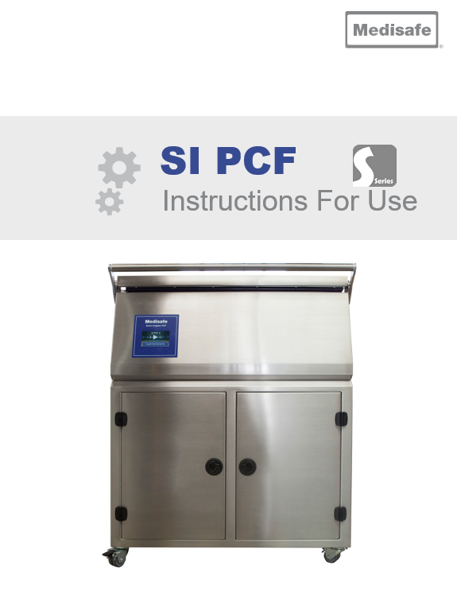

**Intended Use:**

The Medisafe Sonic Irrigator PCF is a High- Pressure, Ultrasonic, Flushing Washer Disinfector for the medical market. It is intended to provide cleaning and low-level thermal disinfection of surgical instruments, including complex lumen/cannulated devices, such as robotic surgical instruments. This is achieved through a combination of ultrasonics and a flushing action to remove debris from both the outside and inside (hollow instruments only) of items placed within the wash tank

**Product features:**

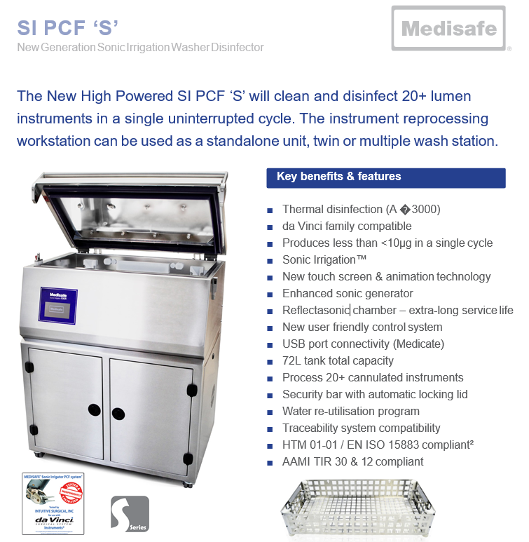

**Technical Specifications**

|  |  |  |  |  |
| --- | --- | --- | --- | --- |
| **General** | | | | |
| Description | | | Medical Device Class IIb | |
| Intended Purpose | | | Internal and external cleaning of surgical instruments, hollow-ware, and associated products | |
| Operating Process | | | Ultrasonic activity, Spray Ports and Irrigation Ports | |
| Classifications | | | Class 1 electric shock protection, externally powered No applied parts  IP rating – IPX0 (refer to BS EN 60601-1, para 6.3)  Not suitable for use in an oxygen rich environment Mode of operation – intended for continuous use | |
| Lid | | | Locking lid prevents access to wash chamber during cycle | |
| Deluge Wash | | | Top Spray in lid | |
| Irrigation | | | With ten ports open each basket manifold outputs produces up to 3 bar (43.5psi) pressure with a flow rate of 50ml/s | |
| Basket Connection | | | Drop and Lock for easy irrigation connection | |
| **User Interface** | | | | | |
| Display | | TFT Touch Screen | | | |
| **Standard Basket** | | | | | |
| Features | | | Four 5-way manifolds, one in each corner | | |
| Din Basket Compatibility | | | Full DIN Tray Standard to hold instruments (M20044) – Length 484mm (19in) Width 253mm (10in) Height 76mm (3in) | | |
| Tray Compatibility size | | | Length 668mm (26.3in) Width 338mm (13.3in) Height 76mm (3in) Trays up to a height of 126mm (5in) fit, but will limit cleaning efficacy | | |
| Interior Dimensions | | | Length 668mm (26.3in) Width 338mm (13.3in) Height 126mm (5in) | | |
| Max Load Weight | | | 10kg / 22lb | | |
| **Da Vinci - Si Robotic Basket** | | | | | |
| Features | | | Four 3-way manifolds, one in each corner | | |
| Robot Instrument Capacity | | | 10 | | |
| **Da Vinci - Xi Robotic Basket** | | | | | |
| Features | | | Two 3-way and Two 2-way manifolds, one in each corner | | |
| Robot Instrument Capacity | | | 6 | | |
| **Ultrasonics** | | | | | |
| Frequency | | 34 to 40 kHz dependant on load | | | |
| Features | | Pulsed Degas | | | |
| Auto-tune | | | |
| **Water Supply** | | | | | |
| Back Siphonage Protection | | | | | Integral AB type air gap and weir observing BS EN 1717 |
| **Drainage System** | | | | | |
| Type | | | | | Pumped |
| Drain Connection | | | | | 19mm (¾i*n*) hose tail outlet |
| Overflow | | | | | 48.3mm (1.9*in*) OD outlet |
| Effluent Temp | | | | | 95°C (*203°F*) |
|  | | | | | **Electrical Supply** |
| General | | | | | Mains supply voltage fluctuations up to ±10% of the nominal voltage;  Transient over voltages typically present on the mains supply (Overvoltage Category II).  Pollution Degree 2 |
| MED11100 (Standard) | | | | | Voltage: 200 - 230VAC (Single Phase + Protective Earth)  Frequency: 50Hz Power: 5kW  Site Current Capacity: ≥ 18A per phase  Site MCB and Disconnect Switch Current Rating: 25A Site Wiring Cross-sectional area: 4mm2 |
| **Dimensions** | | | | | |
| Wash Chamber Liquid Volume | | | | | 43 Litres (*11.5US gal*) |
| Wash Chamber Capacity | | | | | 69 Litres (*18.2US gal*) |
| Wash Chamber Dimensions | | | | | Width 750mm (29.5*in*) |
| Depth 365mm (*14.4in*) |
| Height 237mm (*9.3in*) |
| Outer Cabinet Dimensions | | | | | Width 876mm (*34.5in*) |
| Depth 669mm (26*.3in*) |
| Height Lid Closed 1123mm (*44.2in*) |
| Height Lid Open 1490mm (*58.7in*) |
| Shipping Container Dimensions | | | | | Width 1060mm (*41.7in*) |
| Depth 880mm (*34.6in*) |
| Height 1280mm (*50.4in*) |
| **Weight** | | | | | |
| Operational weight (*Dry*) | | | | | 150kg (*331lb*) |
| Shipping weight | | | | | 217kg (*479lb*) |
| **Chemicals** | | | | | |
| Storage | | | | | Integral Chemical cupboard for 2 bottles |
| Size and Nature of Bottles | | | | | EDA+ or 3EZyme Fluid: 10L (2.6US gal) plastic bottle |
| Quantity Used per Cycle | | | | | EDA+:360ml (12fl.oz US) or 3EZyme:360ml (12fl.oz US) |
| **Environmental conditions** | | | | | |
| Use | | | | | Indoor, Altitude up to 2000m (*6562ft*) |
| Ambient Operating Temperature | | | | | 5°C - 40°C (*41°F - 104°F*) |
| Humidity | | | | | Maximum relative humidity 80% for temperatures up to 31°C (*87.8°F*) decreasing linearly to 50% relative humidity at 40°C (*104°F*) |
| Noise | | | | | Max SPL 68dBA @ 1m from the front of the machine |
| **Internal Data Storage** | | | | | |
| Type | | | | | Micro SD FLASH Card |
| Typical Capacity | | | | | 4GB (1 Million cycles) |
| **Standard** | | | | | **Description** |
| BS EN ISO 15883-1:2009 +A1:2014 | | | | | Washer-disinfectors. General requirements, terms and definitions and test |
| MDD 93/42/EEC | | | | | Medical Device Directive |
| BS EN ISO 15883-2:2009 | | | | | Washer-disinfectors - Requirements and tests for washer- disinfectors employing thermal disinfection for surgical instruments, anaesthetic equipment, bowls, dishes, receivers, utensils,  glassware, etc. |
| BS EN 61010-1:2010 | | | | | Safety requirements for electrical equipment for measurement, control, and laboratory use |
| BS EN 61010-2-040:2015 | | | | | Particular requirements for sterilizers and washer-disinfectors used to treat medical materials |
| BS EN 60601-1-6:2010+A1:2015 | | | | | Medical electrical equipment. General requirements for basic safety and essential performance |
| BS EN 60601-1:2006 +A12:2014 | | | | | Medical electrical equipment. General requirements for basic safety and essential performance |
| BS EN 60601-1-2:2007 | | | | | Medical electrical equipment. General requirements for basic safety  and essential performance. Collateral Standard. Electromagnetic disturbances. Requirements and tests |
| BS EN 62366-1:2015 | | | | | Medical devices. Application of usability engineering to medical devices |
| BS EN ISO 13485:2012 | | | | | Medical devices - Quality management systems |
| BS EN ISO 14971:2012 | | | | | Medical devices - Application of risk management to medical devices |
| PD IEC/TR 60878:2015 | | | | | Graphical symbols for electrical equipment in medical practice |
| BS EN 1717:2000 | | | | | Protection against pollution of potable water in water installations and general requirements of devices to prevent pollution by  backflow |
| PD 5304:2014 | | | | | Guidance on the safe use of machinery |
| EN 61326: 2013 | | | | | Electrical equipment for measurement, control and laboratory use. EMC requirements. General requirements |
| UL 61010-1-2nd Edition | | | | | Safety Requirements for Electrical Equipment for Measurement, Control, and Laboratory Use |
| 2003/10/EC | | | | | Minimum health and safety requirements regarding the exposure of workers to the risks arising from physical agents (noise) |
| 2009/104/EC | | | | | Minimum safety and health requirements for the use of work equipment by workers at work |

**Daily Maintenance**

|  |  |
| --- | --- |
|  | **Before Every Cycle**  1. Visually check that there is enough  chemical for the next wash.  Replenish as necessary  2. Remove, clean and refit the tank filter,  checking the O-ring is still attached  and not damaged  3. Check O-rings still attached to the  four basket docking ports on the  tank  4. Check the wash tank is free from any  debris or deposits  5. Check the spray nozzles for  blockage  6. Check the condition of basket  irrigation port Luer hoses, ensure they  are not kinked or ruptured.  **Daily Checks**  1. Automatic control test - select a recent  printout and compare parameters with  the first printout generated after  installation  2. Check that there is sufficient chemical  for the days planned use  3. Check and clean all internal surfaces  above the water line  4. Check and clean all external surfaces  including lid seal  5. Check mains power cord is not  trapped, damaged, and the plug is  secure in its socket (if fitted)  6. Check lid and lid seal for any damage |

**Basket Removal & Insertion:**

|  |  |
| --- | --- |
|  | **Basket Removal**  To remove the basket, open the lid of the machine and pull the handles up to disengage the latch, then lift from the machine. |
|  | **Basket Insertion**  Ensure the basket is correctly oriented such that the irrigation ports are at the front of the machine. Lower the basket into the machine pushing down on the handles.  Push down until the side latches engage on both sides of the tank as shown. |

**Information for Use:**

|  |  |
| --- | --- |
|  | **Power-Up**  Turn on the power to the machine using the  isolation switch on the wall.  When the machine is turned on, it conducts a  Power-On Self-Test (POST) to ensure the  machine is ready for use.  This process takes a few seconds to configure  the machine and check the basic operation of  the control system, memory and sensor  interfaces. |
|  | The SI PCF is controlled using a touch screen menu. The scroll arrows are used to cycle through the menu pages. |
|  | |