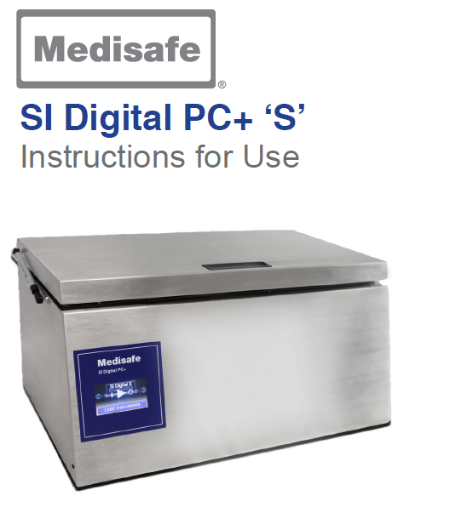

**Intended Use:**

The Medisafe Sonic Irrigator Semi-Automatic is principally intended to clean hollow (cannulated) instruments, surgical instruments, and associated products. This is achieved through a combination of ultrasonic activity and low-frequency Cannulated Pulse Enhancement (CPE) fluid re-circulation to dislodge and flush away unwanted debris from both the outside and the inside (hollow instruments only) of items placed in the wash tank.

**Product features:**

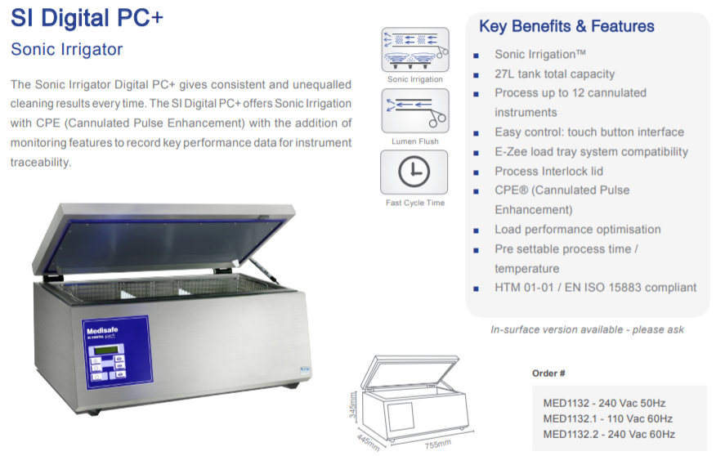

**Technical Specifications**

**General:**

Medisafe Part No: MED1132 (240V)

MED1132.1 (110V)

Model: Medisafe SI Digital  Cannulated Instrument Cleaner

Description: Medical Device Class I

Intended Purpose: Internal and external

cleaning of surgical instruments and associated products

Operating Process: Ultrasonic activity

Applied Standards:

BS2745: part 1: 1993

BS2745: part 3: 1993

EN60101-1:2001 (2nd Edition) EN61010-2-045 (2001)

EN61326: 1997 A1: 1998 EN980

**Wash Cycle Parameters:**

Min. Temp. During Cycle: determined by

temperature of water used

Max. Temp. During Cycle: determined by

temperature of water used

Vol. of Dispensed Chemicals:not applicable

**Required Services:**

*Electricity Supply:*

Supply Voltage: Single phase, 230V

nominal (+/- 10%) @ 50Hz

or 110-120v @ 60Hz

Power Consumption: 900Va max (operational

mode)

0.5Va max (stand-by mode)

Termination: Mains connection plug Lead Length: 1.83m (6 feet)

*Water Supply:*

Supply Connection: n/a

Optimum pressure: n/a Acceptable Pressure Range: n/a Effect of Lower Pressure: n/a Acceptable Flow Rate: n/a Effect of Reduced Flow: n/a Volume Used per Cycle: 26 litres

Acceptable Temp. Range: 16 - 54OC.

Hardness: not more than 5mg/L (5ppm) CaCo3

*Drain:*

Discharge Orifice Type: 18mm outside

dia. unthreaded hose tail

Max. Flow to Drain: 10 litres/min Max. Temp. of Effluent: determined by

temperature of water used

**Daily Maintenance**

|  |  |
| --- | --- |
|  | **Before every cycle**  Perform the following procedure after each  wash cycle:  **Replace drain filter in wash tank**  Carefully remove the small, caged filter  located in the drain inside the wash  tank. Replace with a new item. |
|  | **Wipe water level sensor in tank**  Carefully wipe any excess moisture or  dirt from the water level sensor using a  lint free cloth, soft brush, or an alcohol  impregnated swab.  **Drain wash tank in the following**  **way:**  Connect hose to drain tap and place  other end into a suitable drain  Open tap on drain valve  Press and hold the ‘speed drain’ button  on front, right-hand side of the unit  until wash tank is empty |

**Loading and connection a Basket**

|  |  |
| --- | --- |
| **Loading a Basket in Preparation for a Wash Cycle**  Up to 6 hollow (cannulated) instruments may be  connected to the irrigation system using a suitable  combination of tubes and connectors.  The irrigation port will automatically flush liquid  through the instruments when the quick connect  male fitting on the end of the hose and luer assembly  is pushed into the manifold port on the basket  (shown to the right).  The connector on the hose and luer assembly should  be fitted to a suitable port on the instrument to be  cleaned, or by using a correctly sized Distal Connector.  **Hollow (cannulated) Instruments**  1. Connect a hose and luer assembly to the flush  port on a cannulated instrument using either  a luer lock connector or a suitably sized Distal  Connector  2. Ensure that all instrument taps are in the open  position and carefully position instruments  within the basket using the instrument organiser  supplied  3. Connect open end of hose and luer assembly  to the manifold ports in the side of the basket.  Apply firm pressure and push the connectors  straight into the ports  4. If not already in place, lower the basket into  the wash tank and connect to the irrigation port  on the bottom of the wash tank (shown to the  right). Apply firm pressure and push the connector  straight into the port |  |

|  |
| --- |
| Daily Checks The following checks should be performed daily. Check cleanliness of all external surfaces The outside of the unit may be cleaned by wiping with a decontaminant wash. Check lid and lid seal Inspect the lid seal for any signs of damage.  The lid seal may be cleaned in the same way as the external surfaces.  Take care not to damage the seal during cleaning.  Ensure that lid can be opened and closed without restriction. Check that the wash tank is clean and free from any deposits. The wash tank may be cleaned by wiping with a decontaminant wash or suit- able disinfectant. Check condition of hose connecting basket to port in wash tank. Ensure that hose is not kinked or ruptured. |

**Additional Information:**

|  |
| --- |
|  |